# Endian Settings

Endian was installed with two network adapters, Red is the one facing internet and green is the one facing local network, DHCP was enabled on both the networks and following settings were done on the GUI

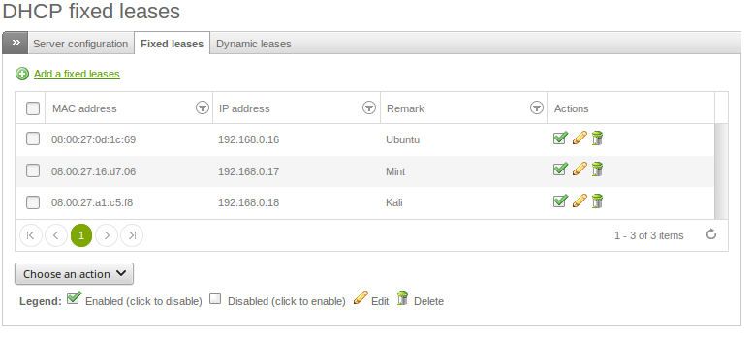

DHCP server is set to fixed leases to ubuntu, mint and kali

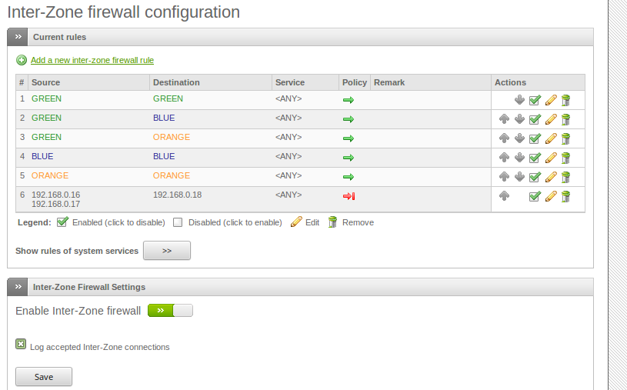

firewall protection is done to stop any communication from ubuntu and mint to kali (0192.168.0.18), since all of them are on the same network and there is no firewall block for kali, kali can reach them.

# Ubuntu Settings

Ubuntu and mint was setup with same configurations, and will automatically get ip from the endian DHCP server.

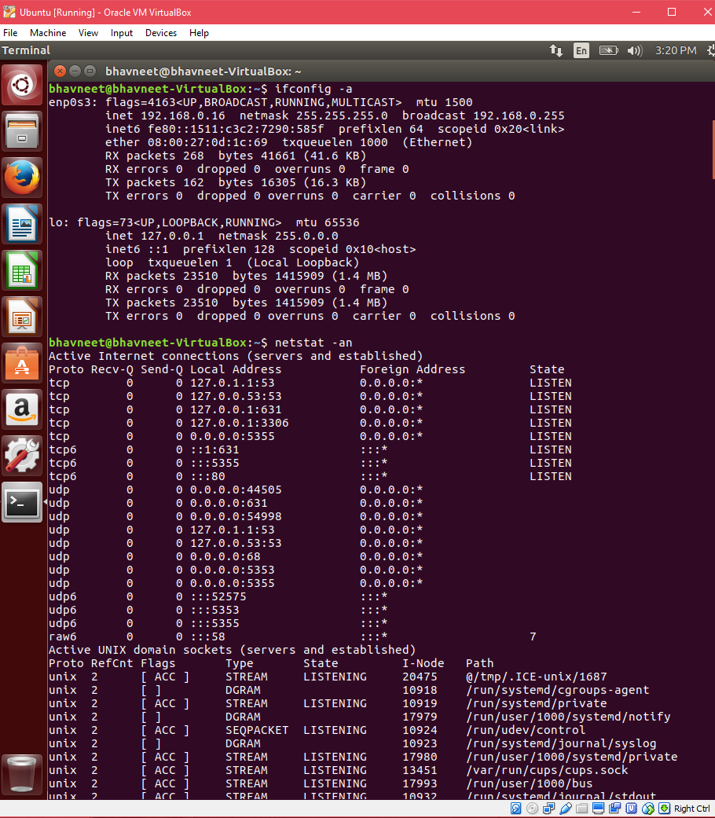

# Mint Settings

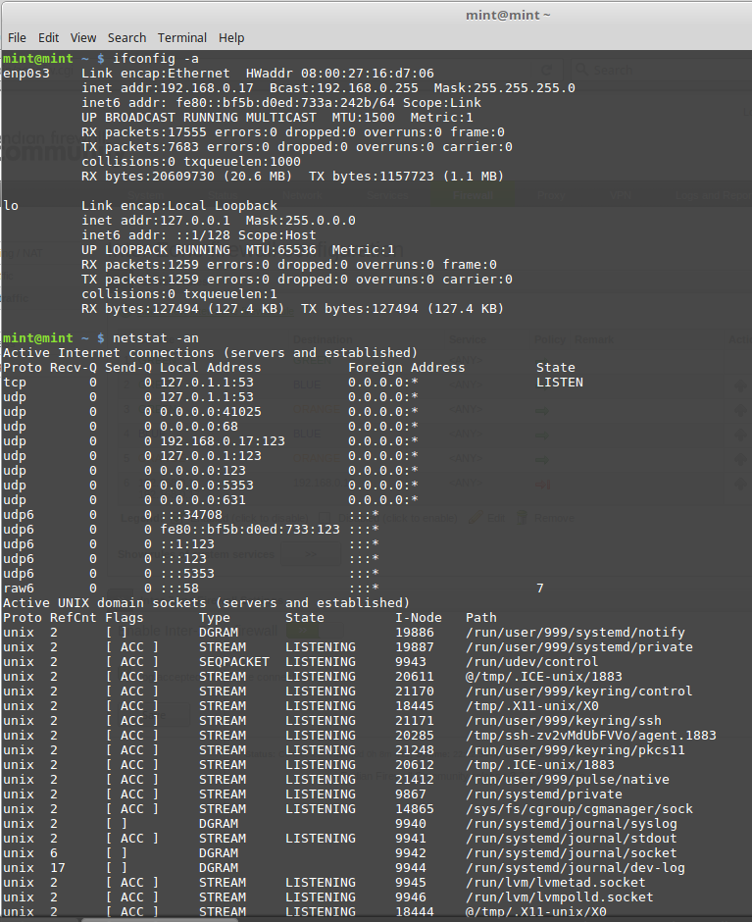

# Kali Settings

For kali two network adapters were enabled, one that is connected to endian firewall and other is just connected to NAT so that it can connect to internet directly

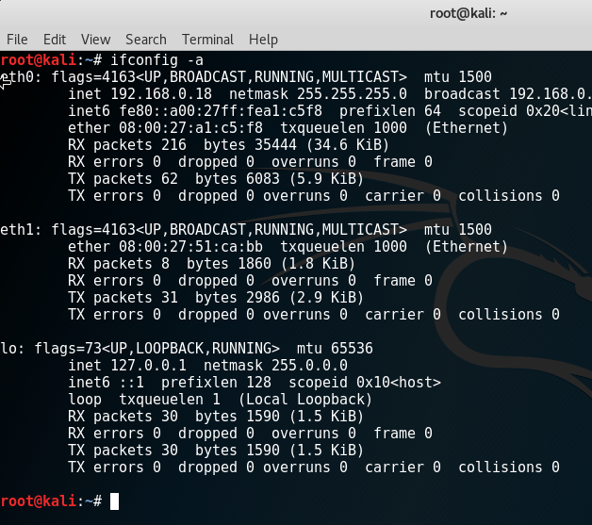

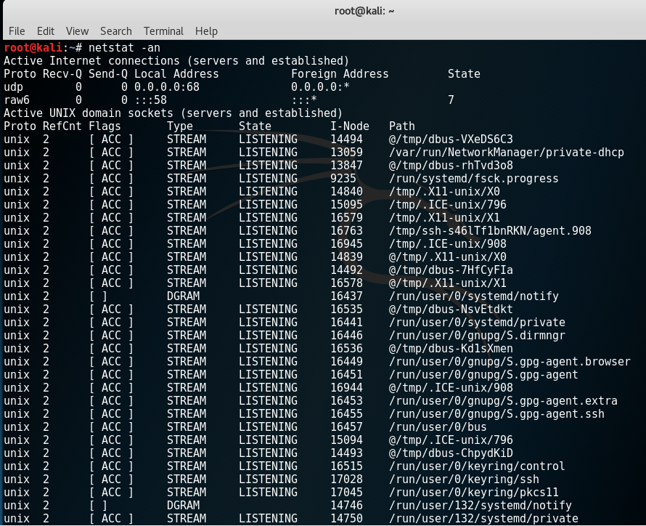

# Metaplosible Settings

it connected to kali network alone

